Predicting Student Dropout Risk
Capstone Project — Steps 1 through 5
Dataset: UCI “Predict Students’ Dropout and Academic Success”
Realinho et al. (2021) · UCI Machine Learning Repository · DOI 10.24432/C5MC89

Step 1: Problem Understanding & Framing
Business Problem
Universities need to identify the students that are at risk early enough to provide targeted academic, financial, and counselling support. This will result in improving retention and allowing limited support resources to be allocated more effectively. Protecting revenue and rankings is a secondary consequence, not something this project measures directly.
Data Science Problem
Using demographic, admission, socioeconomic, and academic information available in the early stages of study, predict whether a student will ultimately drop out. Which variables truly qualify as “early-stage” is resolved explicitly in Step 3.
Task Type
Binary classification. Target = 1 (Dropout) vs 0 (Not Dropout, combining Enrolled and Graduate). This is a supervised learning problem, not clustering where every student in the dataset already has a known, labeled outcome.
Metric | Type | Why it was chosen
ROC-AUC | Technical | Overall discrimination ability across all thresholds
Dropout Recall | Technical | Missing an at-risk student costs more than a false alarm
F1-score | Technical | Balances precision and recall for the Dropout class
Intervention Coverage | Business KPI | Share of actual dropouts flagged for support at a chosen threshold

There is no intervention outcome data available, so the project cannot claim that flagging students will reduce dropout. Results are framed as supporting targeted intervention, not as a guaranteed reduction in dropout rate.

Step 2: Data Collection & Understanding
Dataset Overview
The dataset covers 4,424 students at a Portuguese higher-education institution across 17 undergraduate courses, with 36 raw features plus the Target. It combines demographics, socioeconomic data, application details, 1st/2nd-semester academic performance, and regional macroeconomic indicators. Of the 36 features, 18 are categorical and 18 are numerical. There are 0 missing values and 0 duplicate rows across all 4,424 records.
Outcome | Count | Share
Graduate | 2,209 | 49.9%
Dropout | 1,421 | 32.1%
Enrolled | 794 | 17.9%

For the binary framing used in this project, it was Dropout 1,421 (32.1%) vs Not Dropout 3,003 (67.9%) .This is a moderate imbalance, consistent with the choice of ROC-AUC and Recall over plain Accuracy in Step 1.
Variable | Type | Description | Range / Values
Marital status | Categorical (coded) | Student's marital status | 6 categories
Application mode | Categorical (coded) | Route by which the student applied | 18 categories
Application order | Integer | Preference rank of this course in the student's application | 0 (first choice) to 9 (last choice)
Course | Categorical (coded) | Degree program enrolled in | 17 categories
Daytime/evening attendance | Binary | Whether classes are daytime or evening | 1 = daytime, 0 = evening
Previous qualification | Categorical (coded) | Type of qualification held before enrolling | 17 categories
Previous qualification (grade) | Continuous | Grade of that prior qualification | 95–190 (observed)
Nationality | Categorical (coded) | Student's nationality | 21 categories
Mother's / Father's qualification | Categorical (coded) | Highest qualification of each parent | 29 / 34 categories
Mother's / Father's occupation | Categorical (coded) | Occupation of each parent | 32 / 46 categories
Admission grade | Continuous | Grade used for admission to the course | 95–190 (observed)
Displaced | Binary | Whether the student lives away from their permanent residence | 1 = yes, 0 = no
Educational special needs | Binary | Whether the student has a declared special need | 1 = yes, 0 = no
Debtor | Binary | Whether the student has outstanding debt to the institution | 1 = yes, 0 = no
Tuition fees up to date | Binary | Whether tuition payments are current | 1 = yes, 0 = no
Gender | Binary | Student's gender | 1 = male, 0 = female
Scholarship holder | Binary | Whether the student holds a scholarship | 1 = yes, 0 = no
Age at enrollment | Integer | Student's age when they enrolled | 17–70 (observed)
International | Binary | Whether the student is an international student | 1 = yes, 0 = no
Curricular units 1st/2nd sem (credited, enrolled, evaluations, approved, w/o evaluations) | Integer (count) | Counts of course units in each status, per semester | Whole numbers
Curricular units 1st/2nd sem (grade) | Continuous | Average grade achieved that semester | 0–20 (Portuguese grading scale)
Unemployment rate / Inflation rate / GDP | Continuous | Regional macroeconomic indicators at time of enrollment | Percentages / index values
Target | Categorical | Final outcome | Dropout / Enrolled / Graduate (recoded to binary for this project)

Outlier Scan (IQR Method, 18 Numerical Features)
Feature | Share Flagged as Outliers (IQR)
2nd-semester grade | 19.82%
1st-semester grade | 16.41%
1st-semester credited units | 13.04%
2nd-semester credited units | 11.98%
Age at enrolment | 9.97%

Macroeconomic indicators (unemployment, inflation, GDP) had 0 flagged outliers. Several of the flagged variables are zero-inflated, which causes the IQR method to flag legitimate values as outliers so nothing was removed automatically from the dataset.

Step 3: Data Preprocessing, EDA & Feature Engineering
Leakage Decision
12 curricular unit features were excluded from modelling that includes 1st and 2nd semester credited, enrolled, evaluations, approved, grade, and without-evaluations counts. These describe academic activity that happens after enrolment. Since the project's objective is early identification, these features were removed to avoid temporal leakage leaving 24 early-stage predictors from the original data.
Feature | Definition | Distribution
Age_Group | Bucketed age at enrollment | Under 20 (1,952) · 20–24 (1,334) · 25–29 (427) · 30+ (711)
Parental_Qualification_Same | Whether both parents share a qualification category | 1,956 yes / 2,468 no
Parental_Occupation_Same | Whether both parents share an occupation category | 1,752 yes / 2,672 no
Financial_Risk_Flag | Debtor OR tuition not up to date | 785 flagged / 3,639 not

The modelling feature set after engineering totals 28 features which are 19 categorical and 9 numerical.
Preprocessing Pipeline
Numerical features were median-imputed and standardized. Categorical features were most frequent imputed and one-hot encoded. This produced 245 processed columns from the 28-feature modelling set.
Feature Selection (Mutual Information)
A mutual information filter retained the top 20% of the 245 processed columns, selecting 49 features. Tuition fees up to date ranked among the strongest features, followed by Age at enrolment and Previous qualification grade. The engineered Financial_Risk_Flag also showed meaningful association with the target, confirming that it captures useful early-stage signal although it overlaps with its source variables (Debtor and Tuition fees up to date).
Dimensionality Reduction (PCA)
PCA was applied to the 9 standardized numerical features. Eight of the 9 components were required to explain at least 90% of the variance. Three of these numerical features are binary engineered flags with limited shared variance with the continuous features, which is why most components are needed to reach 90%. A 2D PCA projection shows substantial overlap between dropout and non-dropout students confirming there is no clean linear separability in just two dimensions.

Step 4: Model Implementation & Comparison
Models Compared
Five classification models were trained and evaluated on the same held-out test set of 885 students (a 20% split of the 4,424 total, stratified by outcome). The models consist of, Logistic Regression, Decision Tree, Random Forest, XGBoost, and SVM.
Model | ROC-AUC | Dropout Recall | F1-score | Precision | Accuracy
XGBoost | 0.826 | 0.500 | 0.606 | 0.768 | 0.791
Logistic Regression | 0.818 | 0.486 | 0.603 | 0.793 | 0.794
Random Forest | 0.816 | 0.697 | 0.648 | 0.606 | 0.757
SVM | 0.814 | 0.669 | 0.637 | 0.607 | 0.755
Decision Tree | 0.793 | 0.514 | 0.598 | 0.716 | 0.779

Random Forest does not top ROC-AUC, but it wins on the metric that matters most for this problem. It correctly identifies the highest share of students who actually drop out (Dropout Recall 69.7%), while also achieving the highest F1-score and a competitive ROC-AUC.
Hyperparameter Tuning
RandomizedSearchCV (20 parameter combinations × 5-fold cross-validation) was used to tune Random Forest's n_estimators, max_depth, min_samples_leaf, and max_features. The best configuration scored a cross-validation F1 of 0.623, but only F1 0.644 on the held-out test set which was marginally below the untuned baseline's test F1 of 0.648. The baseline generalized better on unseen data than the tuned version, so it was retained as the final model.
Final Model and Business KPI
The final model is Random Forest (untuned baseline). At the chosen operating threshold, it achieves an intervention coverage of 69.72%. 198 of the 284 actual dropout students in the test set were correctly flagged for potential support.

Step 5: Critical Thinking → Ethical AI & Bias Auditing
Model Explainability
SHAP (TreeExplainer) was used to explain the final Random Forest model's predictions for the Dropout class. The strongest predictors were Age at enrolment, Tuition fees up to date, Financial_Risk_Flag, Scholarship holder, and Gender. Older age at enrolment, tuition fees not being up to date, and not holding a scholarship were associated with higher predicted dropout risk. These are patterns learned by the model and should not be interpreted as evidence of causal relationships.

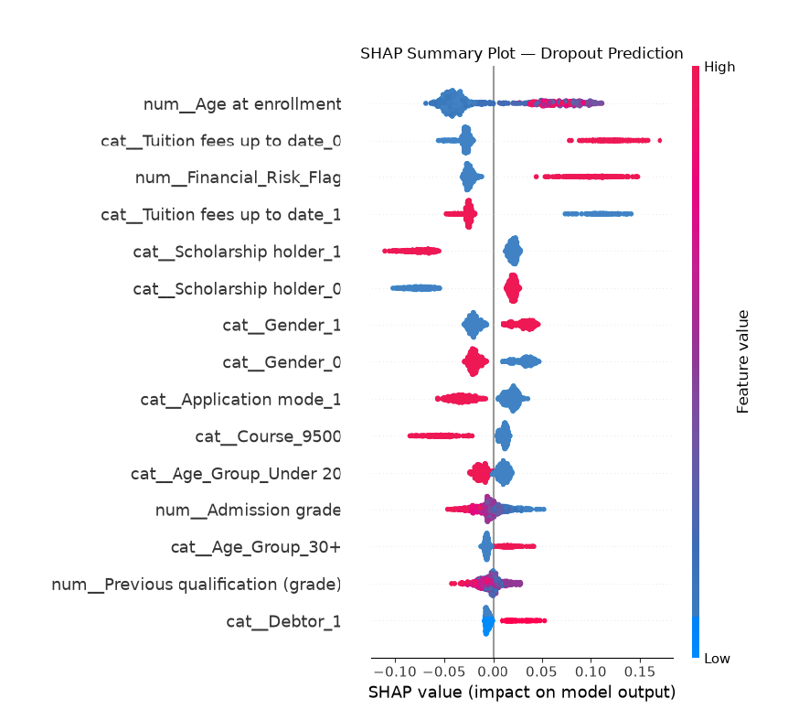

Bias and Fairness Audit
The model's predictions were evaluated across gender and age groups, as these attributes may represent sensitive or potentially protected characteristics.
Gender
Group | N | Actual Dropout Rate | Predicted Dropout Rate | Dropout Recall | False Positive Rate
Gender_1 | 321 | 45.5% | 57.3% | 78.1% | 40.0%
Gender_0 | 564 | 24.5% | 25.4% | 60.9% | 13.9%
Gender fairness metrics:
- Demographic Parity Difference = 0.320
- Disparate Impact = 2.26
- Equal Opportunity Difference = 0.172
The results show substantial differences in model outcomes between the two gender groups. However, the groups also have substantially different observed dropout rates (45.5% vs 24.5%). Therefore, these results demonstrate outcome disparity, but do not by themselves establish that the model is introducing discriminatory bias.
Age Group
Group | N | Actual Dropout Rate | Predicted Dropout Rate | Dropout Recall | False Positive Rate
Under 20 | 412 | 20.4% | 14.3% | 38.1% | 8.2%
Middle (reference) | 323 | 35.0% | 44.6% | 74.3% | 28.6%
30+ | 150 | 58.0% | 82.7% | 94.3% | 66.7%
Age Group fairness metrics (relative to the middle/reference group):
Comparison | Demographic Parity Difference | Disparate Impact | Equal Opportunity Difference
Under 20 | −0.303 | 0.321 | −0.362
30+ | +0.381 | 1.854 | +0.199

The age-group audit also shows substantial differences in model outcomes. In particular, the 30+ group has very high recall (94.3%) but also a high false-positive rate (66.7%). As with gender, these results should be interpreted alongside the underlying dropout rates, which range from 20.4% for Under 20 to 58.0% for the 30+ group.
The disparate-impact ratios observed in the analysis fall outside the commonly referenced 0.8–1.25 range. This provides a useful fairness warning signal but should not be treated as a standalone determination of unfairness.

Limitations and Mitigations
Area | Issue | Potential Mitigation
Class imbalance | 32.1% of the test set are actual dropouts | Class weighting, resampling, or threshold tuning
Fairness disparities | Outcomes differ by gender and age group | Regular subgroup monitoring, group-aware threshold analysis, or reweighting
Data leakage | Features must be available before an intervention decision | Temporal validation and documentation of feature availability
Overfitting | Cross-validation F1 (0.623) differed from held-out test F1 (0.648) | Cross-validation, hold-out testing, and ongoing monitoring
Sensitive features | Gender and age contribute to predictions | Compare performance and fairness with and without these features

